
1.
2.
3.
INTERVENCIÓN AMERICANA EN LA CONSTRUCCIÓN DEL CANAL DE PANAMÁ

INFLUENCIA EN JAPÓN
ASIA
CHINA (1900)

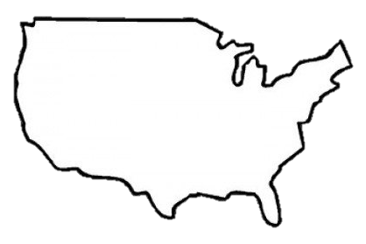

FACTORES

GUERRA CON ESPAÑA(1898)

PANAMA CANAL

AMERICA LATINA

DIPLOMACIA

CAUSAS EFECTOS

TERRITORIOS OBTENIDOS

EFECTO DOMINACIÓN AMERICANA EN CUBA

HAWAII (1898)

COMO SE ANEXIONARON HAWAII
POLITICA DE ROOSVELT

QUE FUE EL BIG STICK
ROOSEVELT


DEFINE DOCTRINA MONROE
MONROE

MOTIVATING FACTORS

SPANISH AMERICAN
How did Mathew Perry’s trip to Japan impact Japan?
Japan begins to trade with the US which they had previously been closed oﬀ to the West. They also starting building a navy as well
1.
Belief in Cultural Superiority (“White Man’s Burden”)
2.
3.
Expand NEW world markets
“Sea Power”
-­‐Build a navy and acquire global naval bases
JAPAN (1853-1854) CHINA (1900)
ASIA
John Hay proposed the ODP, stating that the countries with spheres of inﬂuence in China had to allows us in to trading rights
Explain America’s Open Door Policy
What did the US do that resulted in it building and controlling the Panama Canal?
The US provoked a revolution against Columbia and supported the rebelling Panamanians which in return gave us the right to build and control the Panama Canal Zone

PANAMA CANAL

LATIN AMERICA

WAR (1898)

CAUSES EFFECTS
Define Imperialism in your own words:

What territories does the US gain as a result of winning the war?

Guam
An economic and political domination of a strong nation over other weaker nations

PRESIDENTIAL DIPLOMACIES

Define ROOSEVELT COROLLARY
This was an amendment to the Monroe Doctrine.. It stated that the U.S. would intervene in Latin American affairs when necessary to maintain peace and stability in the Western Hemisphere.
ROOSEVELT
Define BIG STICK DIPLOMACY

Yellow Journalism built up public pressure for war
1.
3.

De Lome Letter amps up Jingoism
American’s sympathize with Cuban Revolution
2.
4.

Blames Spain for the explosion of the USS Maine
Puerto Rico Philippines

Explain how Cuba was impacted

Cuba became a PROTECTORATE of
the US and signed the Platt Amendment

HAWAII (1898)

What Imperialist motives did the US have to ANNEX Hawaii?

America has business investments in Hawaii (ex. sugar) and the Queen was attempting to limit foreign power in the country
Assertion of U.S. dominance Navy is the Big Stick

Define DOLLAR DIPLOMACY
TAFT
The eﬀort of the US to further its aims in LA through use of its economic power by guaranteeing loans made to foreign countries.

Define MORAL DIPLOMACY
WILSON
the system in which support is given only to countries whose moral beliefs are similar to that of the democratic US.

